Device Verification and Validation

# Purpose

This document demonstrates that the finished devices meet the device specifications and the General Safety and Performance Requirements as detailed in documents:

General Safety and Performance Requirements(GSPR): Face Mask Clips

Requirements Specification

# Scope

This document details the methods and results of the testing required to ensure the safety of the product.

# Testing

Verification testing was performed against the requirements specification and in comparing performance with current ear-looped face masks used without clips in Addenbrookes. This testing was conducted with members of the Infection Control team on 17/04/2020 and 20/04/2020. The tests were conducted by physically trying each of the following three designs in turn. Feedback was gathered through unstructured interview.

An attempt was made to gather feedback via feedback forms from ward staff, but the results from this feedback were not of sufficient quality for meaningful conclusions. Key issues included:

* Failure to provide any feedback
* Feedback provided, but only after trying one design
* Feedback provided, but no designs actually tried and tested

Design A

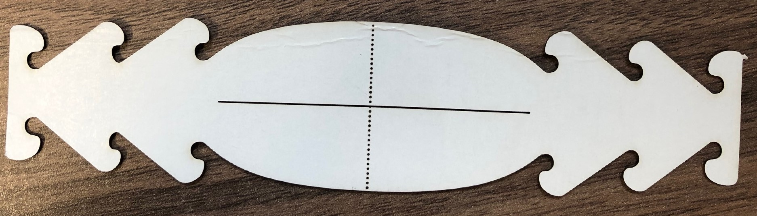

Design B

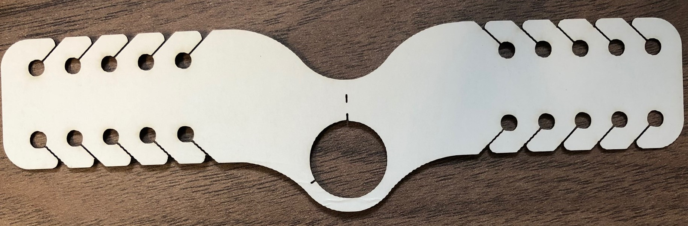

Design C

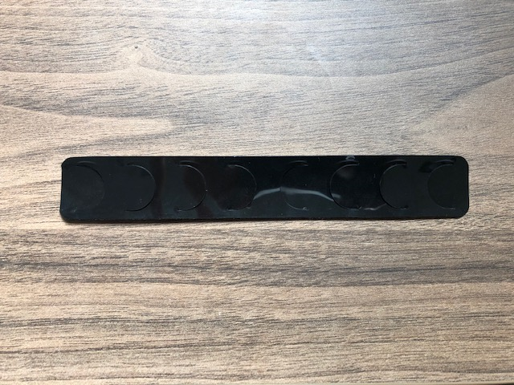

# Results

Three alternative clip designs were evaluated by the Infection Control team.

|  |  |  |  |  |
| --- | --- | --- | --- | --- |
| **Specification** | **Knotted Loops** | **Design A** | **Design B** | **Design C** |
| Design must prevent the elastic ear loops being tightened against the user’s ears | **Fail** | **Pass** | **Pass** | **Pass** |
| The clip should enable surgical masks with ear loops to be tightened such that they fit closely to the face, such that the fit is as effective (or better) as with knotted ear loops | **Pass** - Baseline | **Pass** | **Pass** | **Pass** |
| Design suitable for mass production of at least 10,000 units per day | n/a | **Pass**  Die cutting can produce 10,000 in under 1 hour. 3 days lead time on initial setup. | **Pass**  Die cutting can produce 10,000 in under 1 hour. More complex tool than Design A - longer lead time for setup. | **Pass**  Cut using in-line thermoforming machines. 5p per unit. 2 days lead time on initial setup. |
| < 10p per item | **Pass**  0p | **Pass**  Unit cost 3.5p for initial 100,000 units. | **Pass**  Higher unit cost than Design A, but not fully costed. | **Pass**  Unit cost 5p for initial 100,000 units. |
| Suitable for incineration | **Pass**  Best - no additional material incinerated | **Pass**  2nd best | **Pass**  2nd best | **Pass**  3rd best |
| Minimum material per clip | **Pass**  No material | **Pass** | **Pass** | **Pass** |
| Design should enable users to adjust tightness | **Pass** | **Pass** | **Pass** | **Pass** |
| No sharp corners/edges | **Pass** | **Pass** | **Pass** | **Pass** |
| The clip must not break for a maximum usage duration of 4 hrs | **Pass** | **Pass** | **Pass** | **Pass** |
| Clip profile flat against head, no protrusions | **Pass** | **Pass** | **Pass** | **Pass** |
| Must be provided clean (but not sterile, does NOT need to be sterilisable or resistant to cleaning products) | **Pass** | **Pass**  See Risk File | **Pass**  See Risk File | **Pass**  See Risk File |
| Should not incur increased handling of ‘dirty’ PPE or hair/face/head when doffing | **Pass** | **Pass**  Perforations seen as very advantageous by testers. Some test subjects found this tangled in their hair, however the low incidence of this and improvement with practice mean that the negatives of this were felt to be outweighed by the ease of use of the design. | **Pass**  Perforations seen as very advantageous by testers. | **Pass** |
| The clip should not impact the usage or security of other PPE | **Pass** | **Pass** | **Pass** | **Pass** |

Clinical feedback demonstrated that the clips are all fit for purpose. **Designs A & C were selected for the following reasons:**

**Design A**

Most intuitive to use. Removal by tearing perforations was highly favourable. Cardboard preferred for environmental reasons. Equal first most popular design amongst Infection Control. Quicker and cheaper to manufacture than Design B, and cheaper to manufacture than Design B. However, some testers experienced difficulties getting the hooks tangled in hair on removal.

**Design B**

Did not get tangled in hair, and elastic securement holes prevent separation of clip and surgical mask during doffing. Removal by tearing perforations was highly favourable. However, the design was more complex to manufacture and more expensive than Design A. Additionally, the appearance is more complex than the others, which some found to be counter-intuitive to use. Additionally, the position of the elastic on the clip was hard to change once initial placement of the elastic was done. Least popular design amongst Infection Control.

**Design C**

Did not get tangled in hair easily due to lack of protrusions and smooth plastic surface. Equal first most popular design amongst Infection Control. Most expensive to produce. A little more challenging to use, due to it being difficult to identify the attachment points by feel behind the head without practice.

**Monitoring compliance with and the effectiveness of this document**

This process forms part of a quality system accredited to International Standard EN ISO 9001:2015, EN ISO 13485:2016 and BS 70000:2017. The effectiveness of the process will be monitored in accordance with the methods given in the Quality Manual (CE-QS-QAM-4).

**Equality and diversity statement**

This document complies with the Cambridge University Hospitals NHS Foundation Trust service equality and diversity statement.

**Disclaimer**

It is **your** responsibility to check against the electronic library that this printed out copy is the most recent issue of this document.

**Document management**

|  |  |  |  |
| --- | --- | --- | --- |
| Approval: | Sarah Greasley | | |
| MDAG approval: |  | | |
| Owning department: | Clinical Engineering Innovation | | |
| Author(s): | Sonya Sireau | | |
| Pharmacist: | n/a | | |
| File name: | Device Verification and Validation | | |
| Supersedes: | n/a | | |
| Version number: | 1.0 | Review date: | n/a |
| Local reference: |  | Document ID: |  |